Biodiversity and the Society of Superlatives
By Esteban Suàrez (PhD)
Traveling through the jungles of Yasuní National Park in the Ecuadorian Amazon, it is difficult not to feel stunned by the amount of biological diversity in these forests. Writing about the experience, the difficulty lies in not succumbing to the exhausted turns of phrase and repetitive metaphors commonly used in attempting to depict the biological riches of these ecosystems.
The media — blogs, newspapers, radio, and television programs — is full of references to the vast number of species in tropical ecosystems: “Megadiverse Ecuador;” “Colombia, the most biodiverse country on Earth;” “Life at its purest!” Every tropical country has its own. But the way we use these superlatives and the richness that they try to represent tells us something important about the way in which we perceive and relate to biodiversity and natural systems.
In many senses, our society has turned into a monster that feeds on superlatives and records. Be it our performance, strength, or wealth; the development of our countries or the security of our cities; our perceived beauty, or even our deformities; every aspect of human life is now measured against some hypertrophied version of itself. The tallest, richest, or strongest man. The prettiest girl, or the one with the most piercings or longest nails. The most corrupt country in the world. Our societies have turned into a Guinness book of records in which success and notoriety are commonly sought through the unusual and the extravagant.
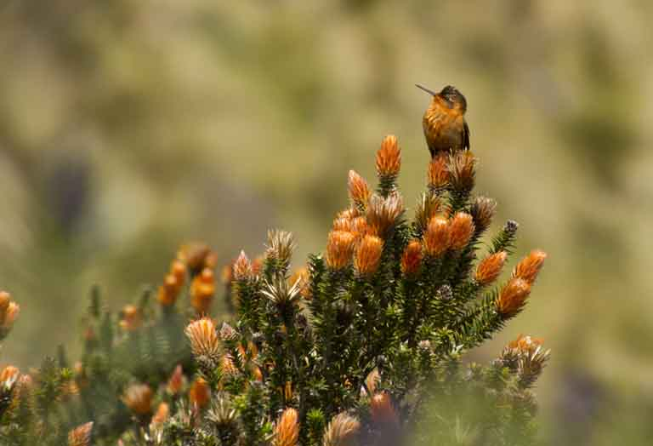
Shining Sunbeam (Aglaeactis cupripennis). This striking hummingbird of the high Andes competes for nectar from Chuquiraga jussieui with other hummingbirds like the Ecuadorian Hillstar (Oreotrochilus Chimborazo). Photo by Esteban Suárez.
This pattern is percolating into our perception of ecosystems and biodiversity. When trying to promote conservation among the general public, we tend to do it not by appealing to the basic right to life that we share with all species, but by publicizing ideas such as “megadiverse ecosystems.”
We sell being the country with the most species on Earth, the one which harbors the most ecosystems, or the region with the largest amount of endemics. We sell having the largest flying bird in the world, the only South American bear, or the tallest mangrove trees on the planet. And in this way, each country or region finds its own superlatives as a way to depict how special and unique it is. The result is a distortion of the criteria and values that we use to motivate and communicate the conservation of biodiversity and ecosystems.
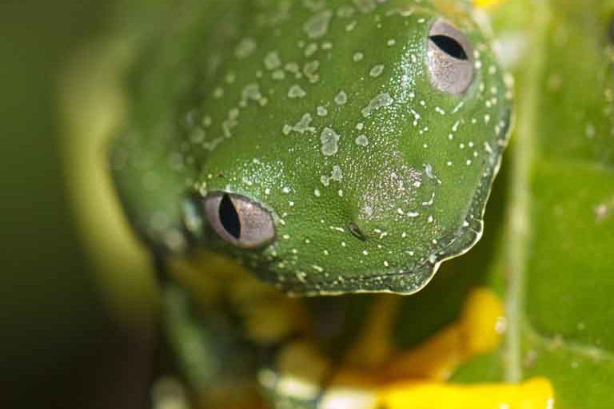
On the one hand, it may seem that the only way to educate people about the importance of nature is through the number of species that inhabit an ecosystem. It is a quantitative measurement, and thus easily explained. But species richness by itself then ends up becoming the only thing that we can rescue, for the collective mind. However, the inescapable corollary is that ecosystems that have low species richness, like alpine environments or the subtropical deserts, must be less important than, for example, a tropical rain forest with its hundreds of thousands of species. This trend also implies that the only measure and approach that we consider for the restoration and conservation of ecosystems is the number of species considered “appropriate” for that ecosystem. As a result, ecological processes are relegated to a secondary role, even if they might be as important as the number of species, especially for the provision of ecosystem services.

Fringed leaf frog (Cruziohyla craspedopus): anphibians are among the most diverse groups of vertebrates in tropical rain forests. Photo by Esteban Suárez.

On the other hand, we take the fact that a given territory is especially rich in biodiversity as a virtue of that country or its inhabitants. For example, Ecuadorians, Colombians, Brazilians, and Peruvians all claim at the same time that each of our countries is the most biodiverse on the planet, carefully selecting the statistics that support our claim, as if the artificial borders that war and politics imposed on the planet a few decades ago had anything to do with the evolutionary processes that gave rise to biodiversity over millions and millions of years. This incapacity to see the world beyond nationalistic divisions is not merely another expression of our exacerbated anthropocentrism, it amounts to a form of gullibility, by which countries, regardless of their ability to protect their natural heritage, take credit for the evolutionary processes that gave rise to the biodiversity within their national boundaries.
Amid this obsession with numbers, we forget that the evolutionary processes that resulted in the awe-inspiring numbers of species in the lowland tropics are the same processes that allowed, in areas with lower biodiversity, for the evolution of organisms with stunning adaptations that allow them to withstand the toughest environmental conditions in mountains, deserts, or temperate regions. Ultimately, the number of species is merely another attribute of ecological systems on this planet, no different from the adaptations that allow species to compete for resources or adapt to extreme environmental conditions.
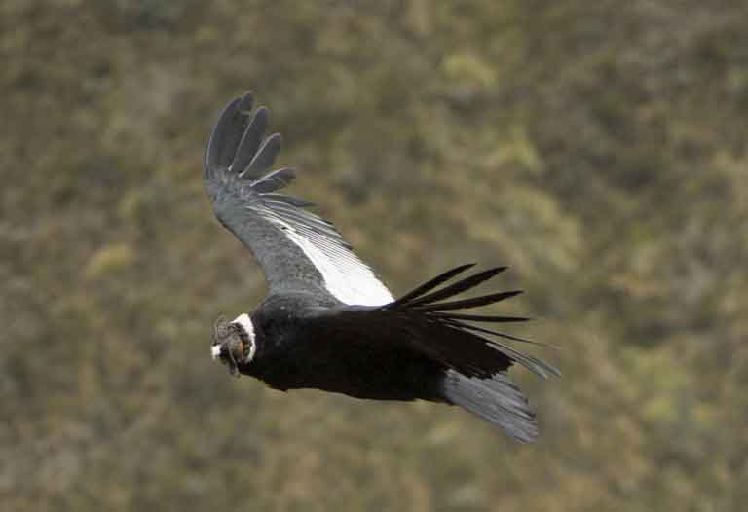
Perpetuating this bias can lead us down two slippery paths. First, it masks the complexity of natural systems and the diversity of life strategies. The importance of an ecosystem is reduced to a measurement of the number of species that it harbors. Second, we end up ignoring the intrinsic value of species and ecosystems. It does not matter how species-poor an ecosystem is: Each of its species represents a unique evolutionary solution that will never repeat itself and, as such, it has the same right to exist as any species inhabiting the richest ecosystem in the world.

Andean Condor: The largest flying bird in the world, but most importantly a crucial player in the trophic web of the Andean cordillera. Photo by Esteban Suárez.

Changing this misplaced emphasis on species richness will require significant reforms in all levels of our education systems. In the name of conservation, Nature has been turned into an economic asset and, in many instances, its usefulness for humans has become the only value that we can bring to light for the common citizen. What is the economic value of natural resources, or how much would it cost to replace natural ecosystem services? If we are to reverse or at least attenuate the negative impacts of our civilization upon the environment, we must move beyond the mercantile mindset of perceiving everything only in terms of numbers, where “more” or “bigger” necessarily mean “better.”
This last thought reminds me of another superlative. Ecuador and other tropical countries have been the first to recognize “rights” to Nature. The right to exist, to be respected, to be protected beyond the needs of our societies. But as fast as we recognized those rights, we have been the first to ignore them. Yet another superlative!
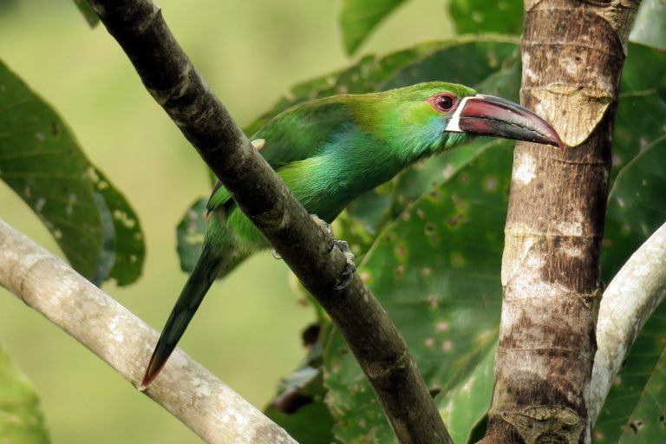Crimson-rumped Toucanet (Aulacorhynchus haematopygus). In the complex forests that flank the Northern Andean cordillera, this toucanet eats fruits, invertebrates, and even small vertebrates, contributing to the trophic dynamics of these ecosystems. Photo by Esteban Suárez.

Esteban Suárez is an Ecuadorian ecologist who has been working for the past 20 years in wildlife conservation and ecology of high-elevation Andean ecosystems. He is a Professor in the Department of Biological and Environmental Sciences at Universidad San Francisco de Quito (Ecuador).

