The Great Pacific Garbage Patch

Information and Images sourced from the National Geographic at https://www.nationalgeographic.org/encyclopedia/great-pacific-garbage-patch/

The Great Pacific Garbage Patch is a collection of marine debris in the North Pacific Ocean. Also known as the Pacific trash vortex, the garbage patch is actually two distinct collections of debris bounded by the massive North Pacific Subtropical Gyre.
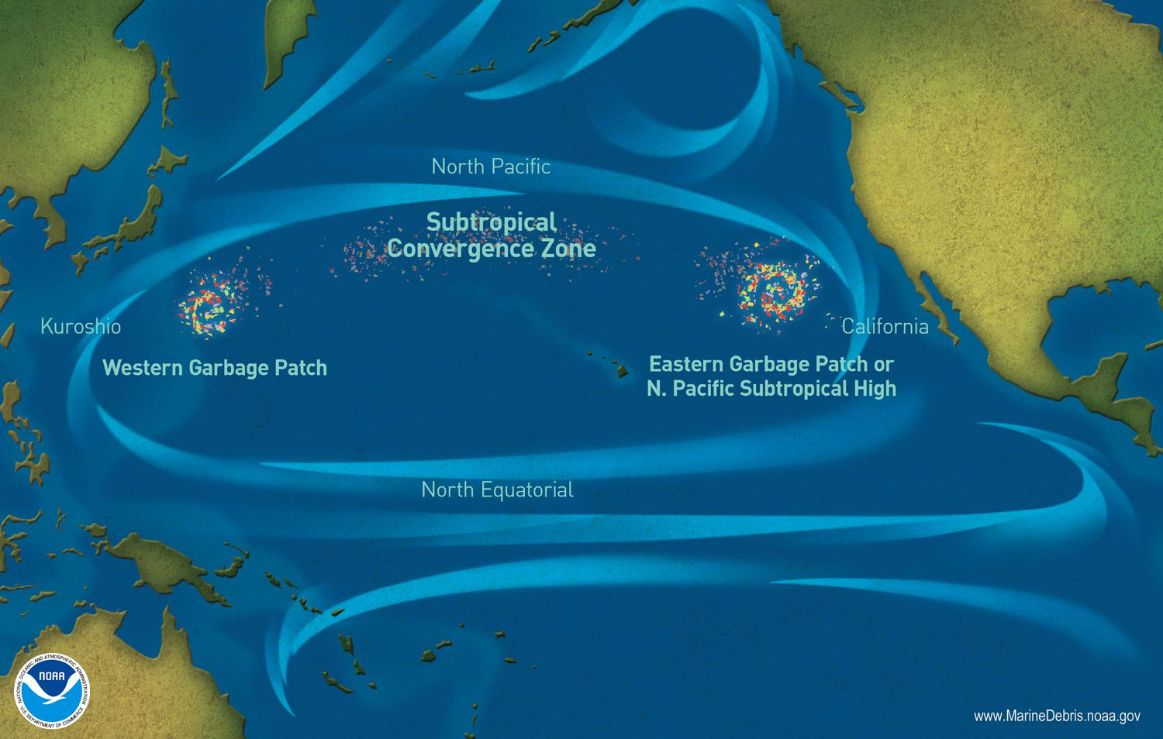

The Great Pacific Garbage Patch sits near the surface of the ocean. Dense debris can sink centimeters or even several meters beneath the surface, making the vortex’s area nearly impossible to measure.
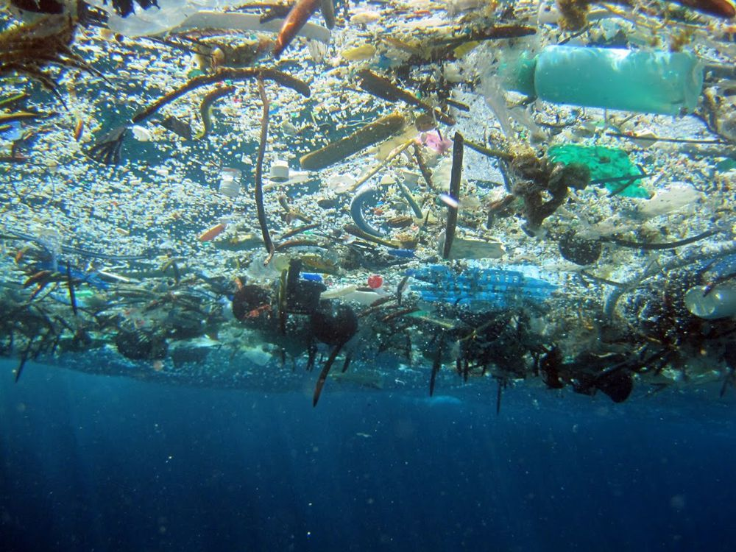
Microplastics
Most debris in the Great Pacific Garbage Patch is plastic. Plastic is not biodegradable, meaning it does not disintegrate—it simply breaks into tinier and tinier pieces, known as microplastics. In the ocean, the sun breaks down these plastics. Microplastics of the Great Pacific Garbage Patch can simply make the water look like a cloudy soup.
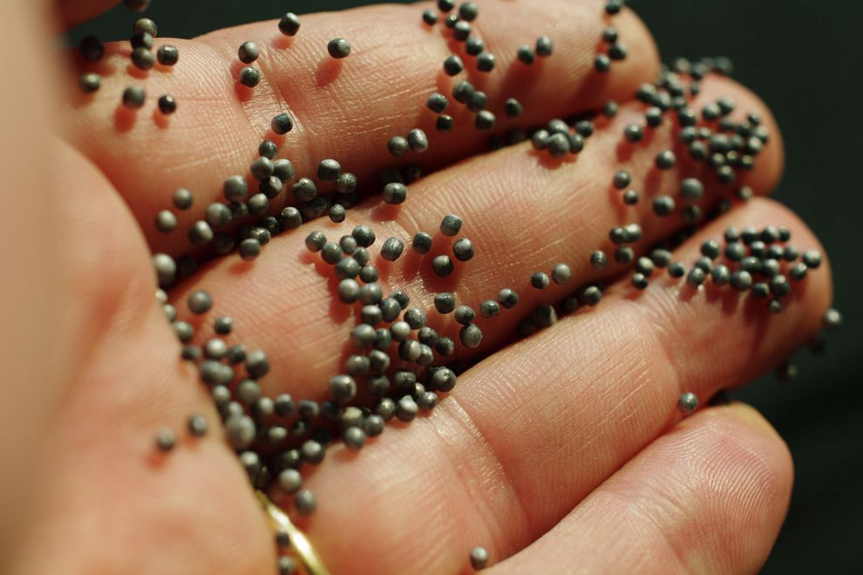

Harm to ecosystems
Marine debris can prevent algae and plankton, the photosynthetic producers in the marine food web, from receiving enough sunlight to create nutrients. When these tiny organisms are threatened, the entire food web is put at risk—first-order consumers that eat the plankton, such as jellies; second-order consumers that eat the jellies, such as turtles; and apex predators such as sharks.
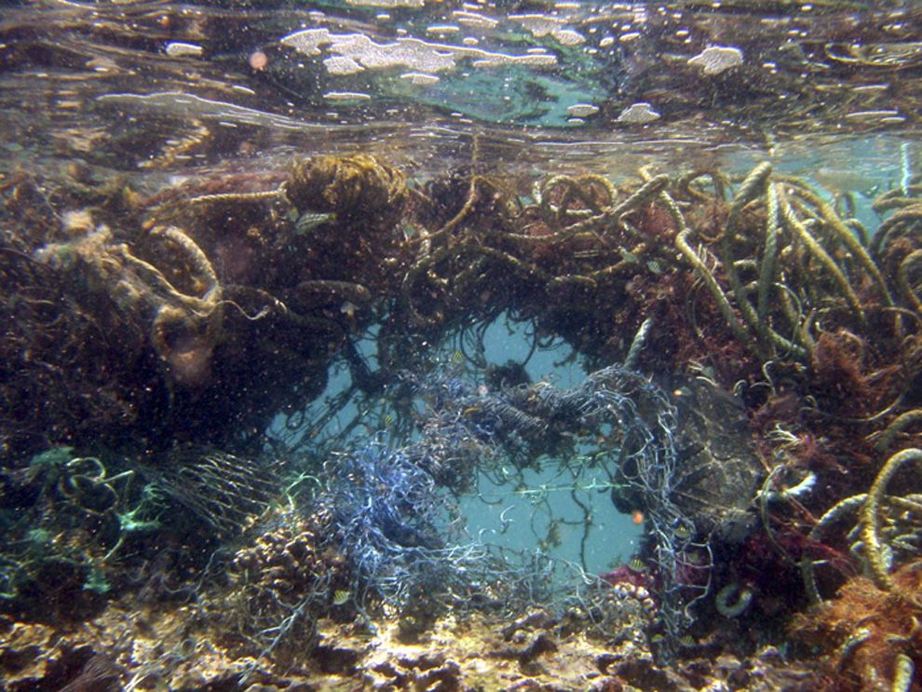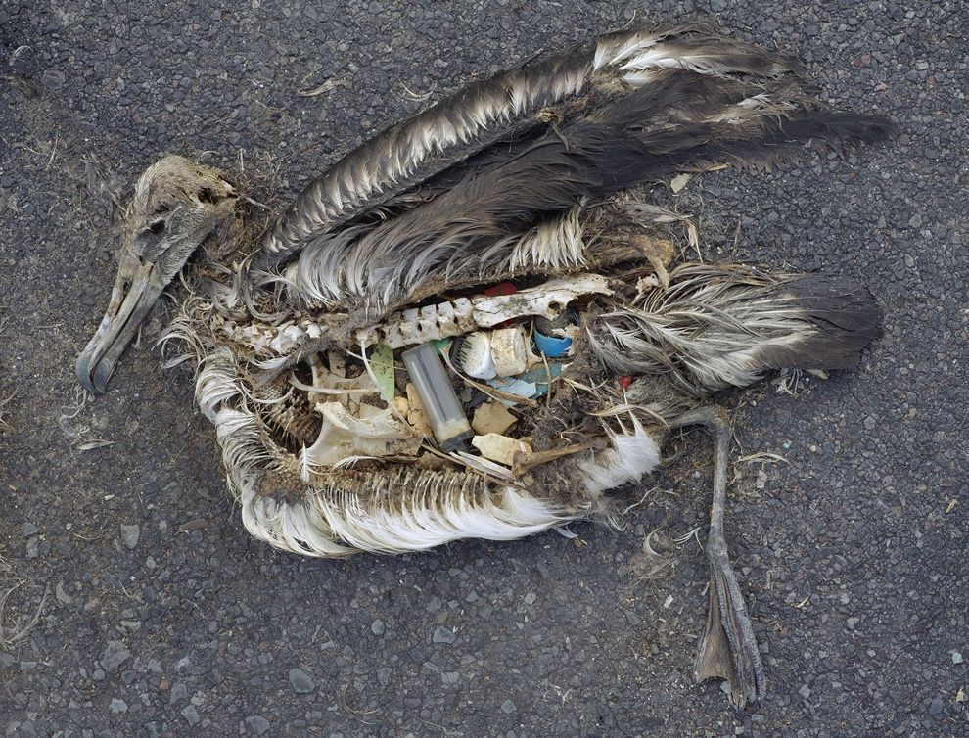
The stomach contents of this unfortunate albatross include plastic marine debris fed to the chick by its parents.

